**1 Registration system**

**1.1 Log in**

1. Click ‘Log in’ when opening the website.
2. Input the username and password.
3. Click ‘Log in’ in the Login Form.

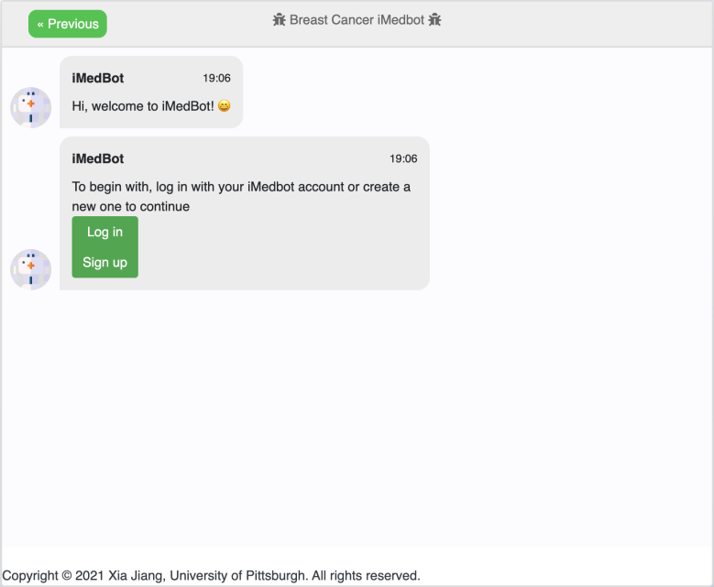

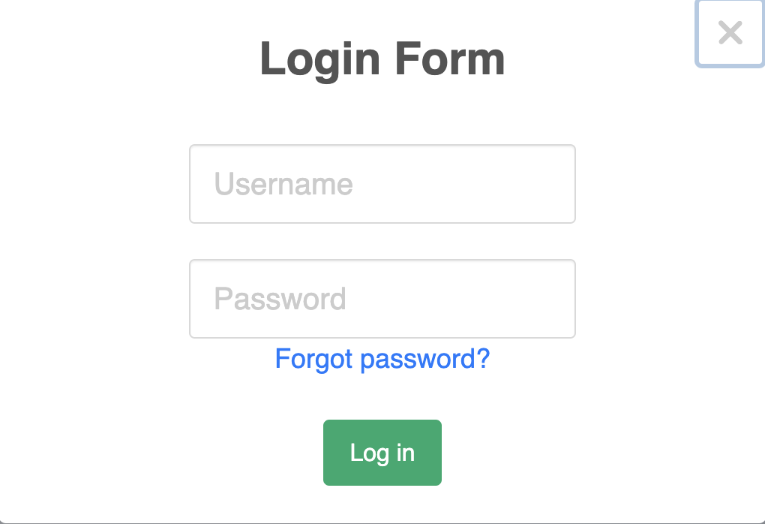

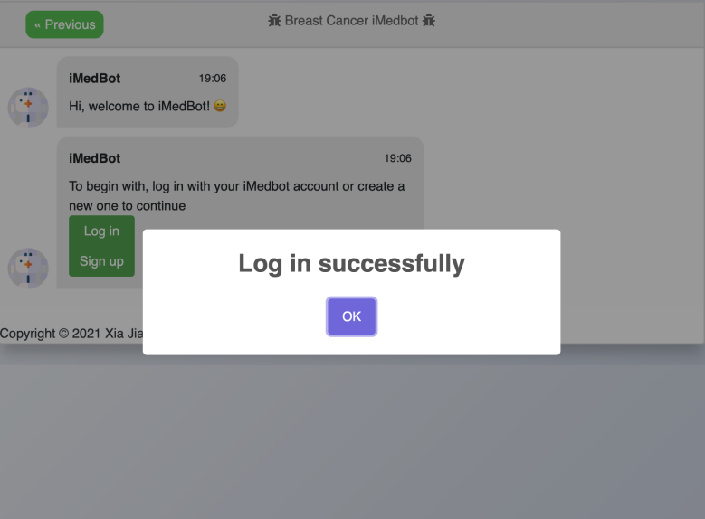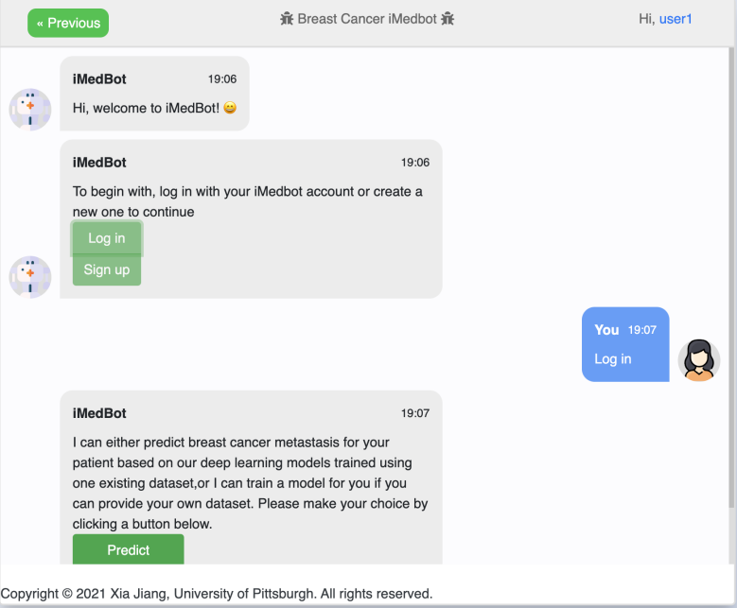

Note: the username and password should be the same as what you sign up.

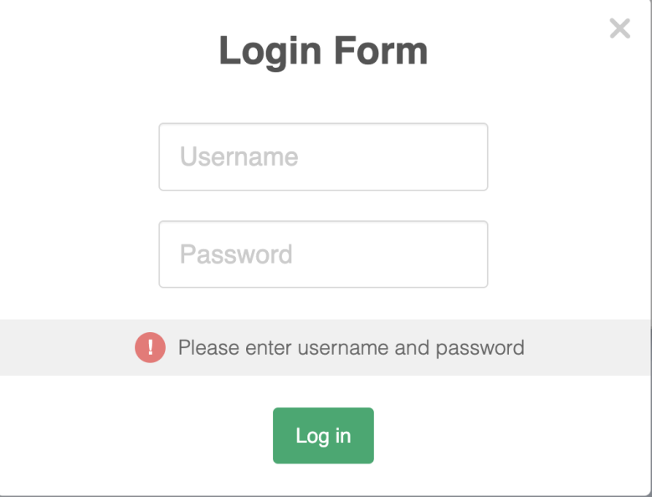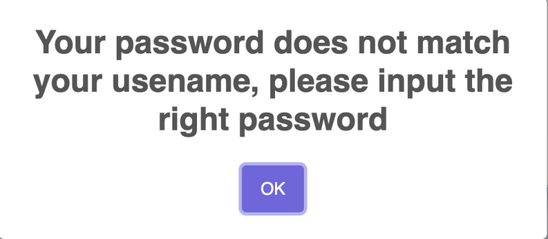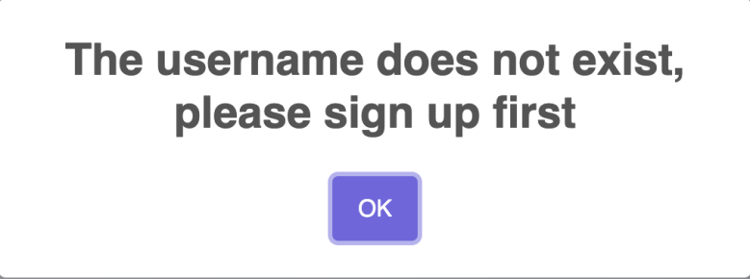

**1.2 Sign up**

a. Click ‘Sign up’ when opening the website.

b. Input the username and password.

The username should be a valid email address

The password has several rules:

1. The length of the password should be greater than 8.
2. The password should contain at least one uppercase character.
3. The password should contain at least one lowercase character.
4. The password should contain at least one number.

c. Confirm the password.

d. Choose a verification question and input your answer. Keep the answer in mind and you can reset password by the answer.

e. Click ‘Sign up’ in the Sign Up Form.

f. Input the verification pin code in your email.

g. Log in with the account you sign up.

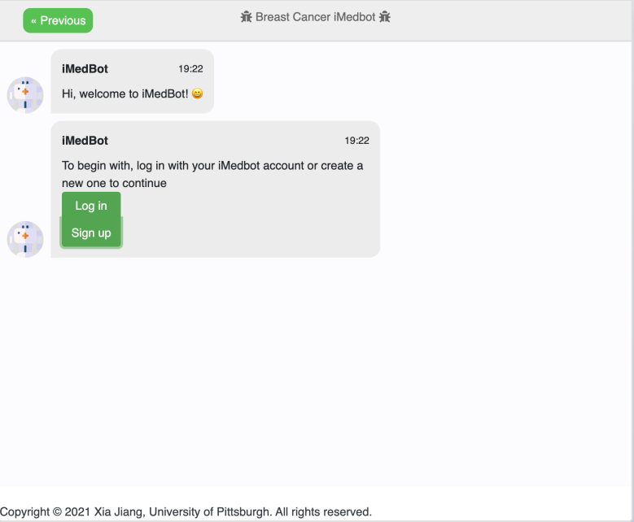

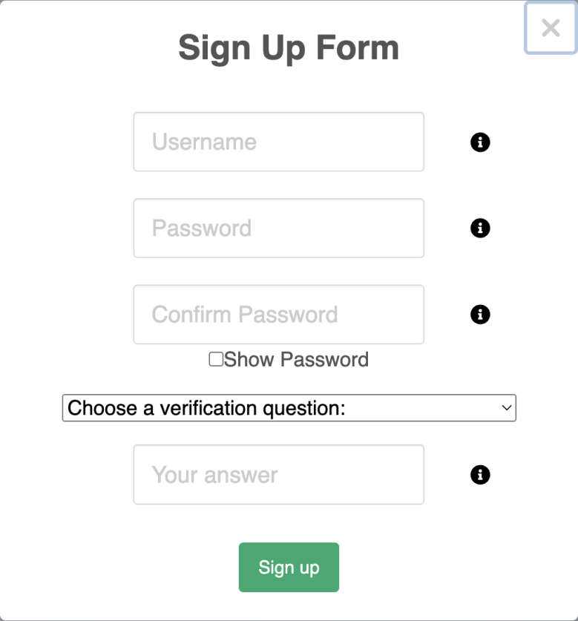

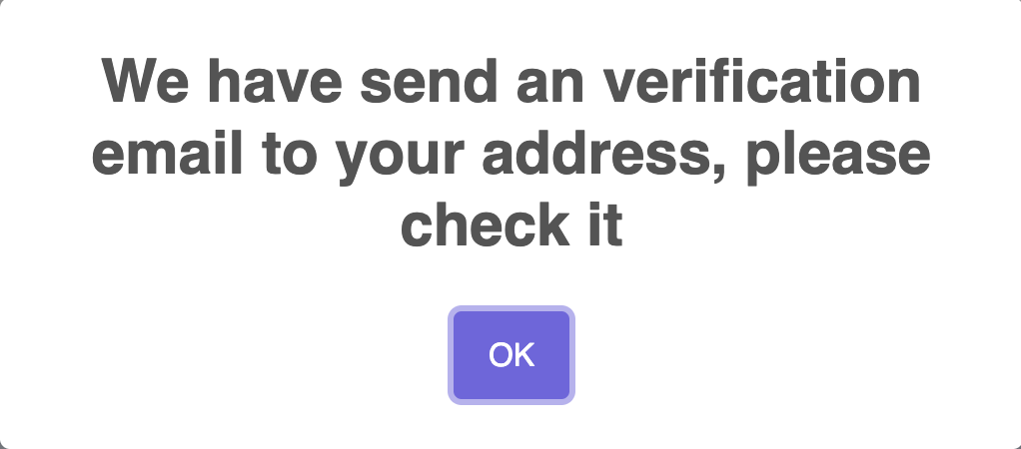

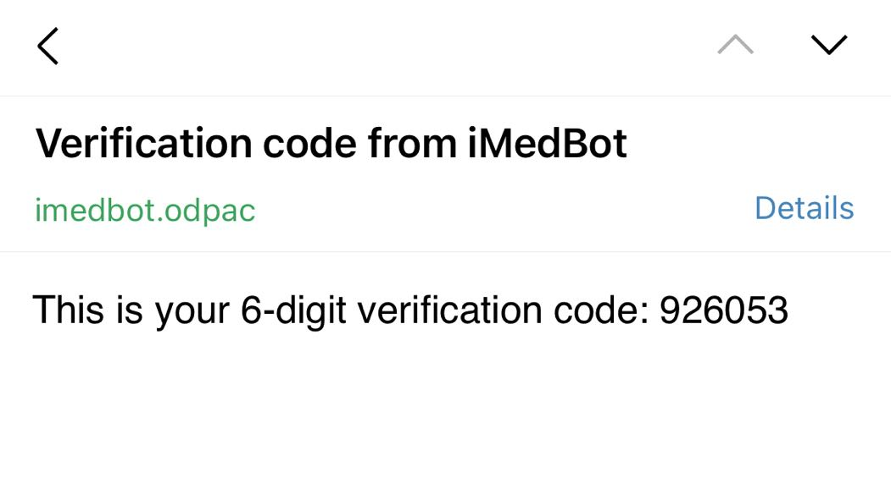

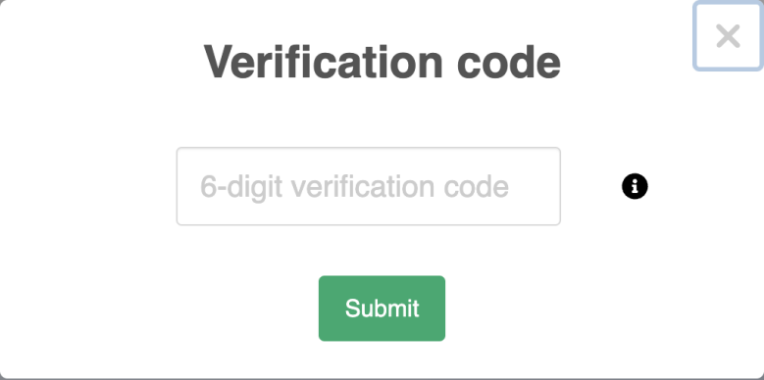

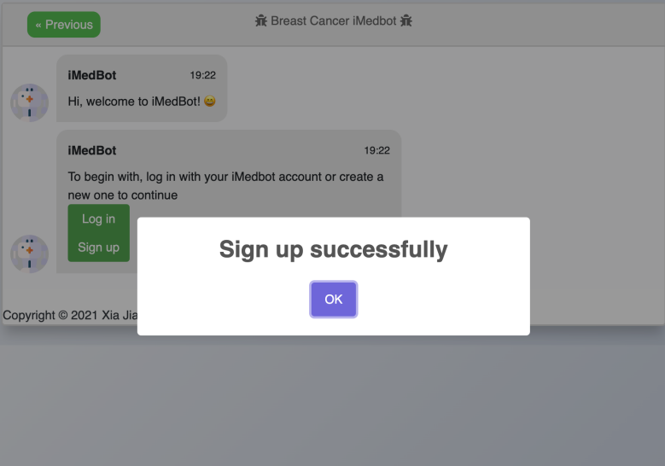

**1.3 Log out**

1. Click the greeting sentence in the upper right corner
2. Click Log out and the website will redirect to the initial state

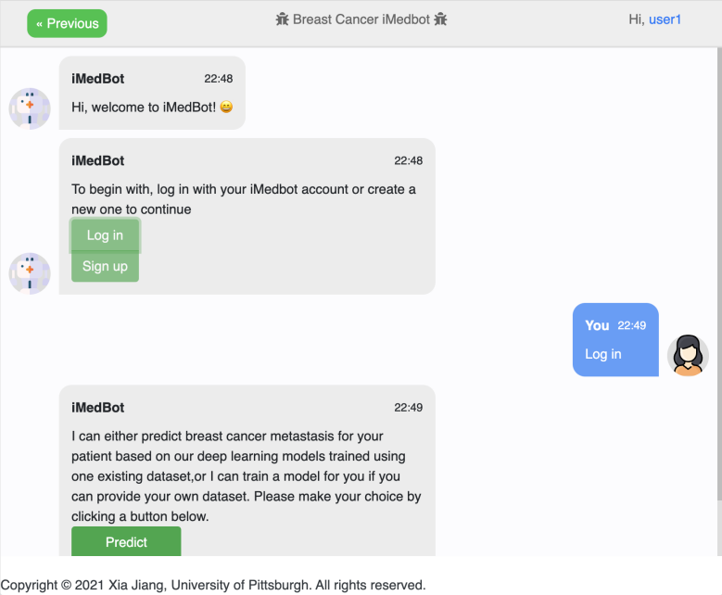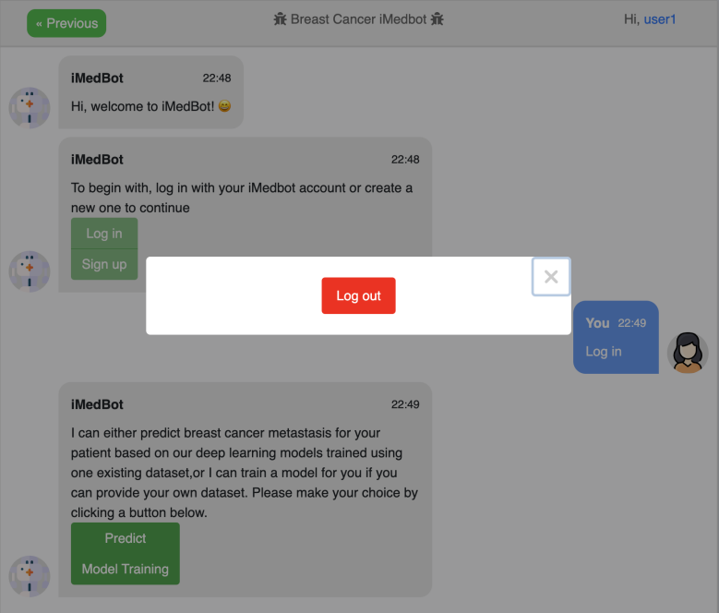

**1.4 Reset password**

1. Click the link of forgot password



b. Input the username of your account

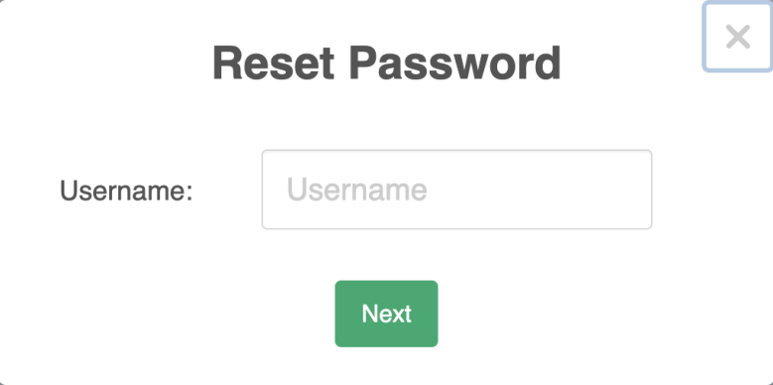

c. Receive the code in your email

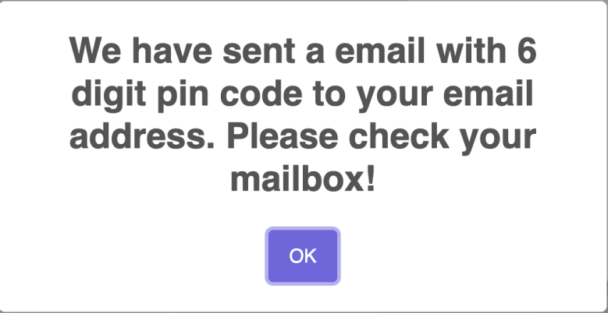

d. Input your answer of verification question and pin code and new password.

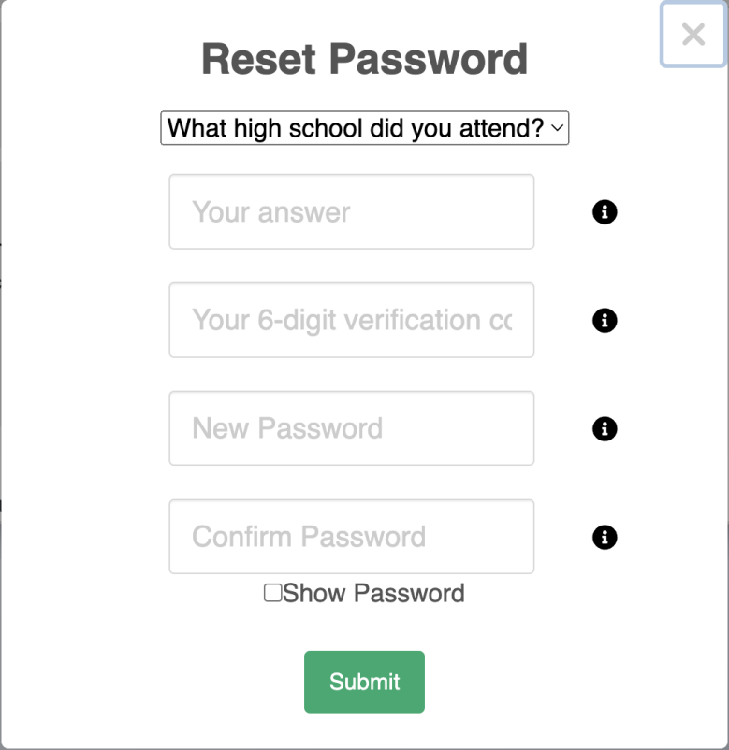

e. Click submit

**2 Predict system**

Predicting module can predict breast cancer metastasis for your patient based on deep learning models trained by iMedBot system using one existing dataset.

1. Click predict after logging in

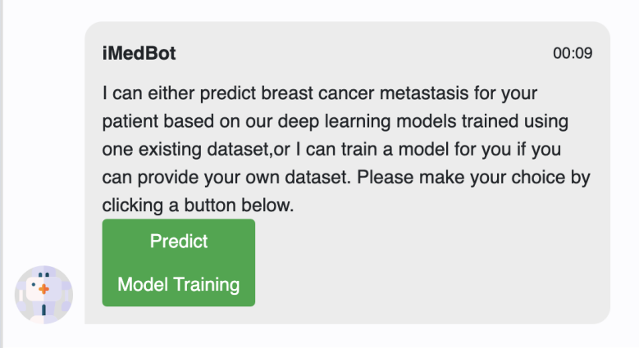

b. Choose a year

There are 3 choices that are 5-year, 10-year and 15-year. Each year has different number of questions and the choices will be predicted by different models.

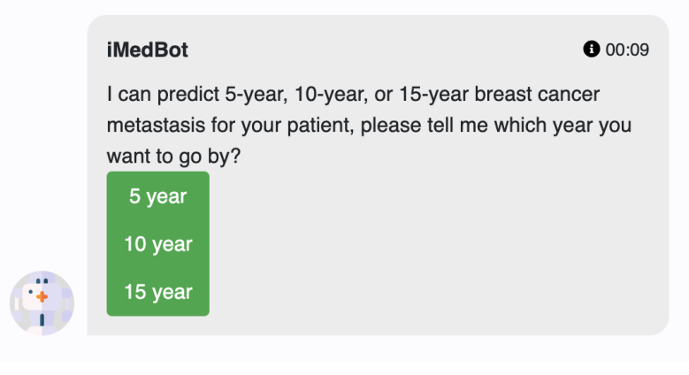

c. Select predictors

There is an explanation for the predictor when you hover around the link.

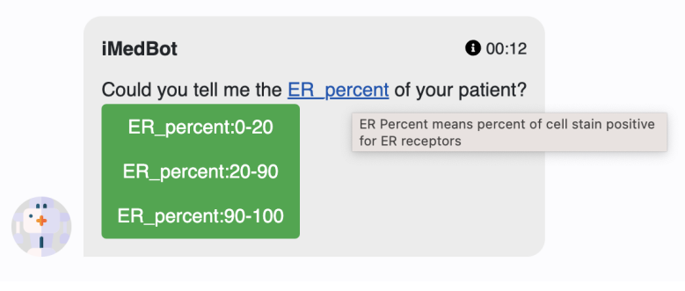

For some complex choices there are explanations when you hover around the buttons.

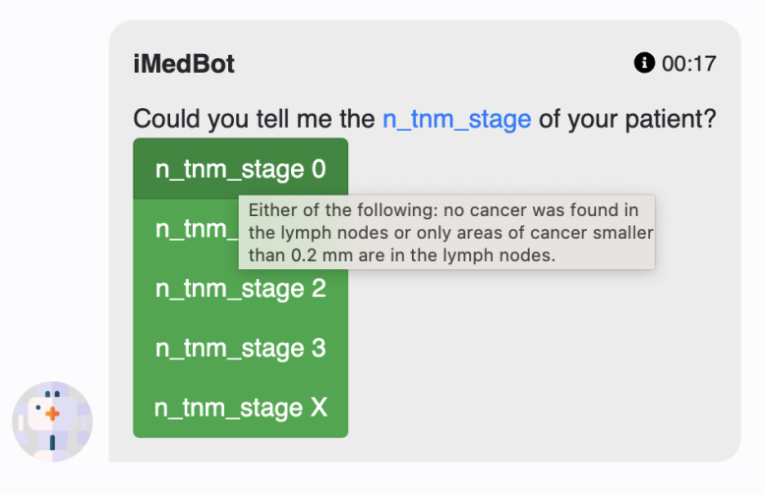

d. See the result

After you finish choosing, the system will return the probability of breast cancer metastasis of corresponding year.

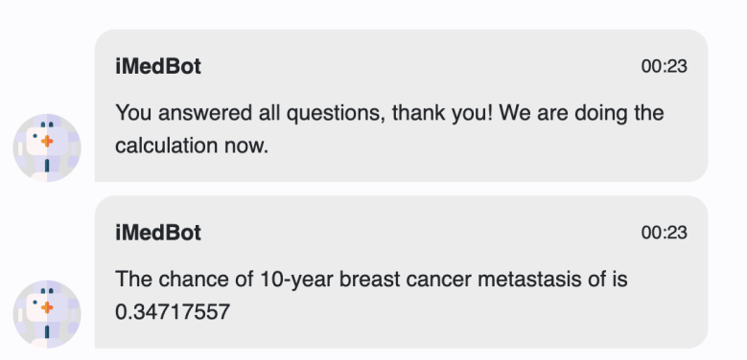

e. Predict another patient

After finishing predicting one patient, you can choose to predict another one or end the task.

1. Predict another patient:

You need to choose the year for another patient and repeat the process above.

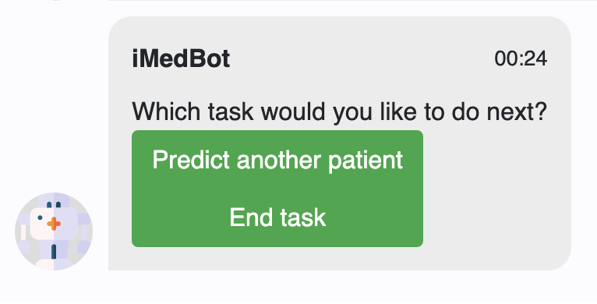

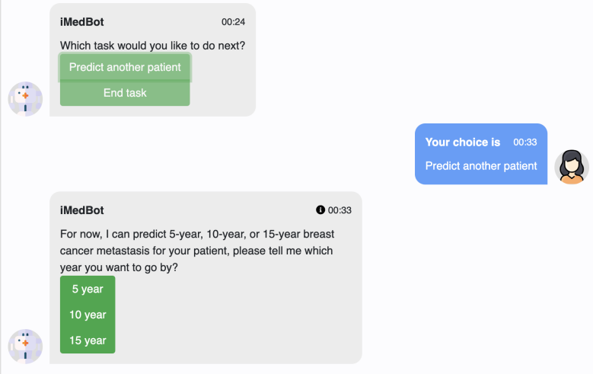

1. End task:

You will need to choose whether to take a survey. If you choose yes, please refer to the survey system. If you choose no, the website will refresh and go to the initial state.

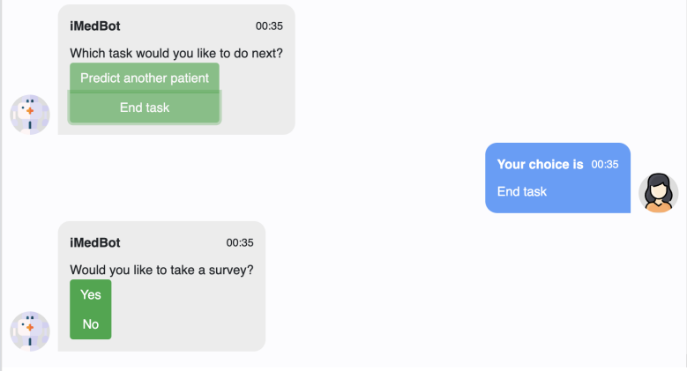

**3 Model training system**

It will use 80% of your dataset to train this model with 5 fold cross validation strategies and 20% dataset as validation dataset to return the validation AUC.

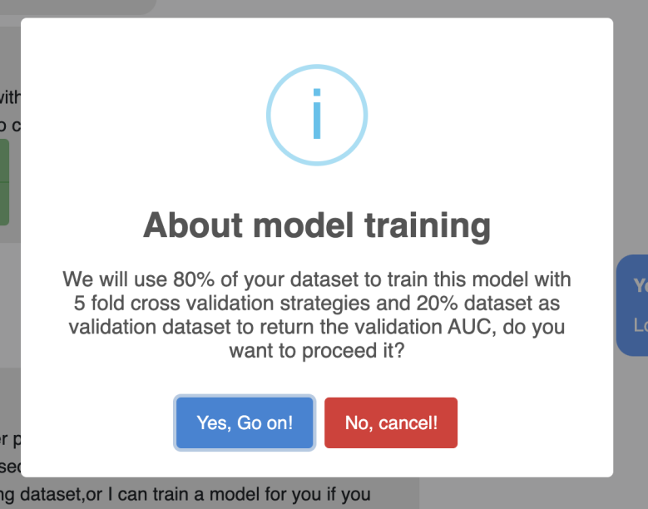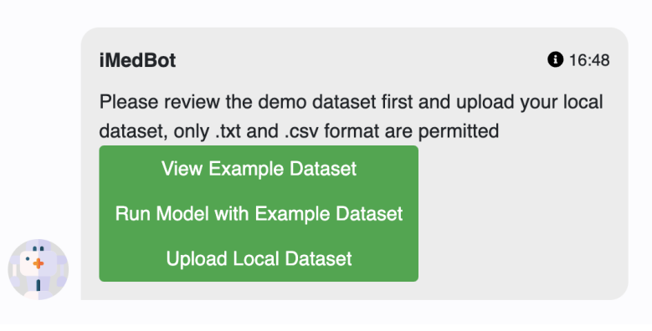

**3.1 View example dataset**

Click view example dataset and you will see the instructions about datasets for model training

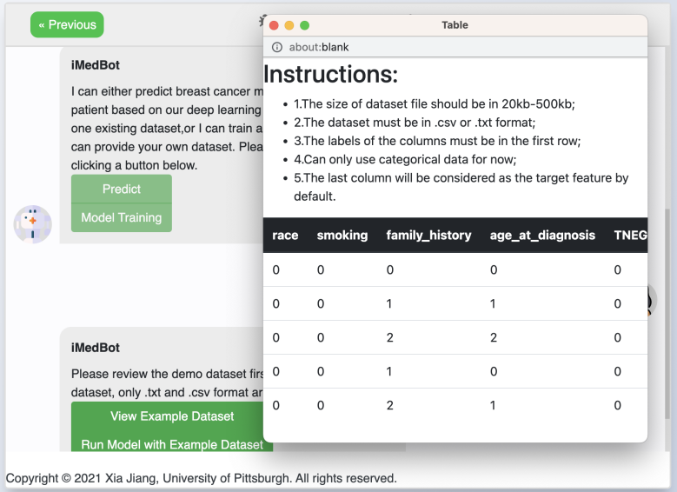

**3.2 Run model with example dataset**

1. Click run model with example dataset
2. Choose whether to use our default parameter setting to train the example dataset

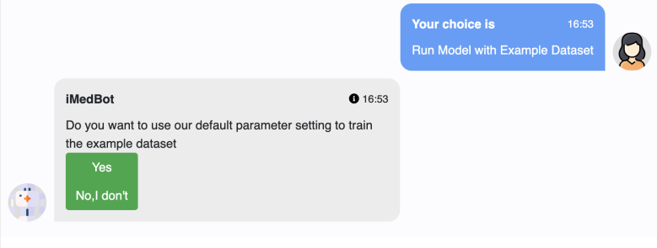

1. Use default parameter setting

After choosing this you will see the list of parameter and explanation will be provided when hovering around the parameter names.

If you choose to change mind, the system will redirect to user defined parameter setting.

If you choose yes, the model begins training. Wait until the system returns results.

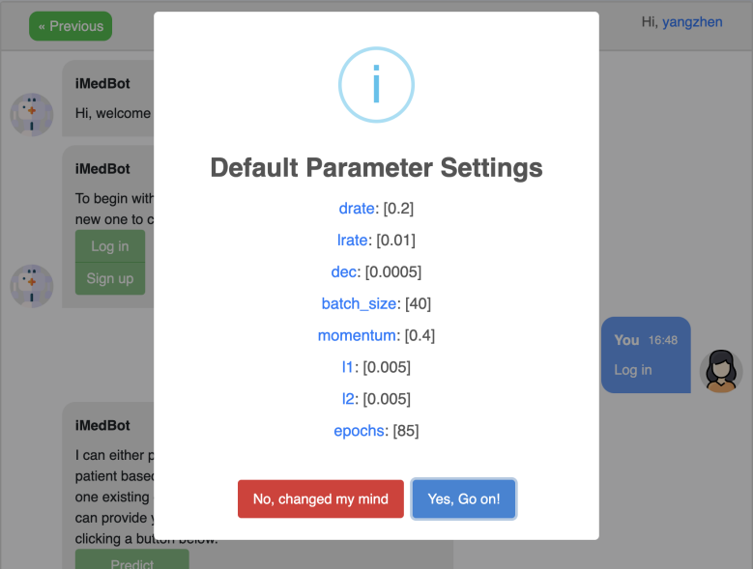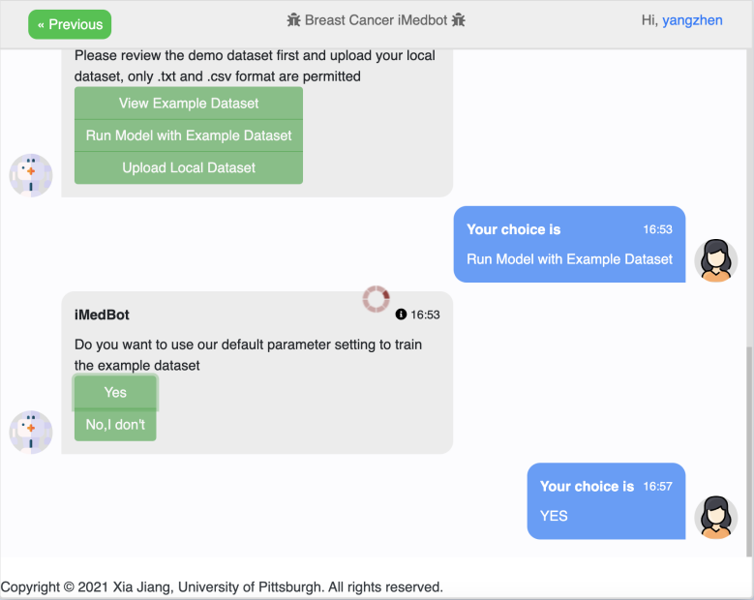

1. Use user defined parameter setting

You can input the parameters by yourself. There will also be explanations for the name of parameters when hovering around.

Click submit and wait for the training process.

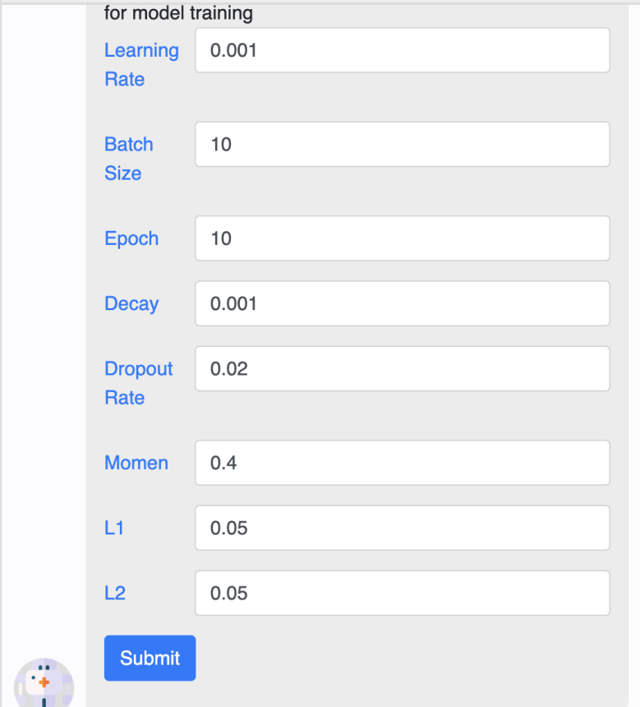

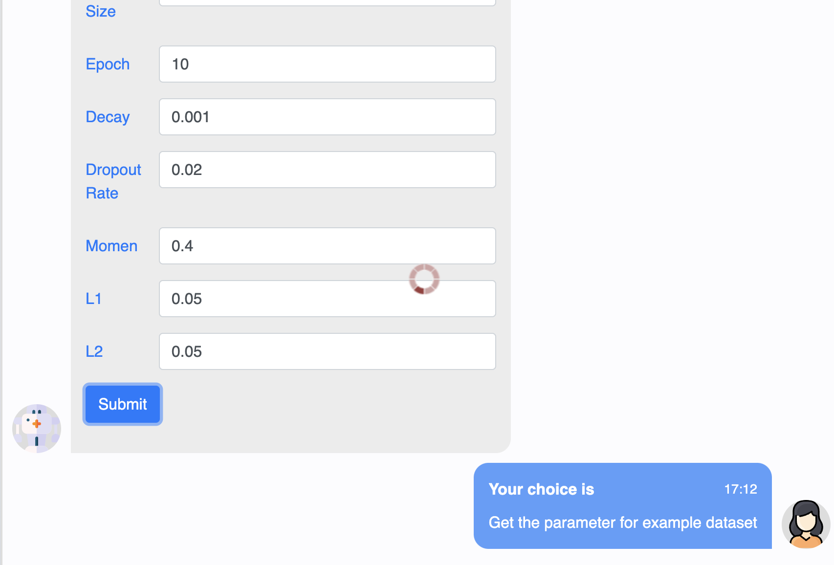

1. See the training result

It will show the validation AUC value and validation ROC_curve plot. And explanation of AUC_ROC will be provided if you are not familiar with it.

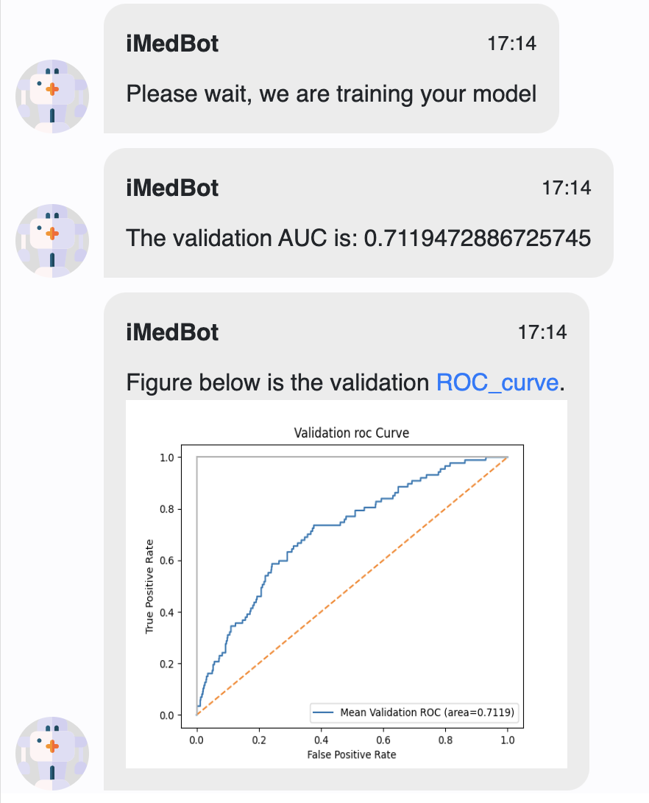

**3.3 Upload local dataset**

1. Click upload local dataset
2. Read the instructions for dataset and confirm

If the uploaded dataset does not meet the requirements, the file will be rejected and you need to re-upload the file.

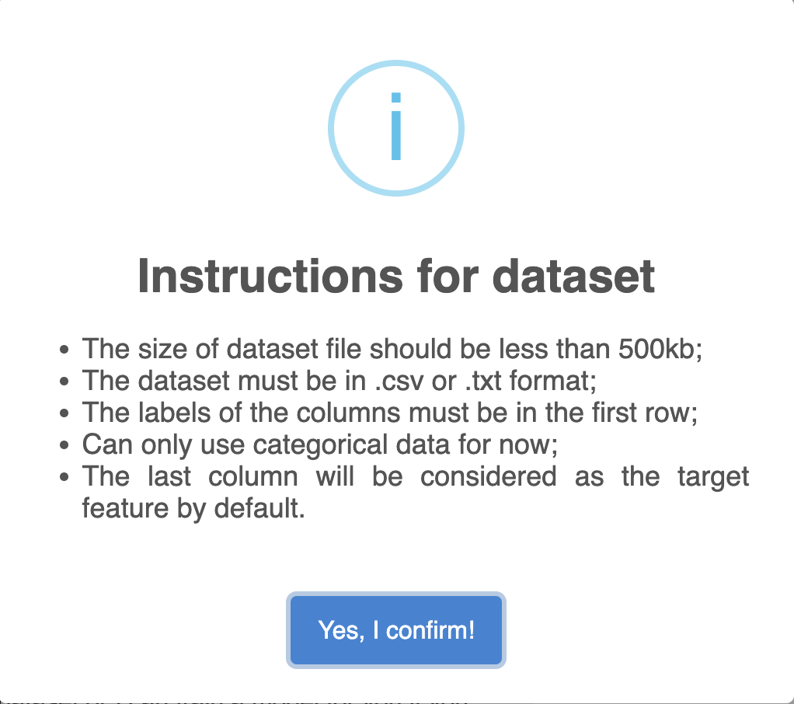

1. Choose the dataset file and upload

Select the dataset file you want to upload in your local file system and open the file. Then the dataset file will be uploaded to the system.

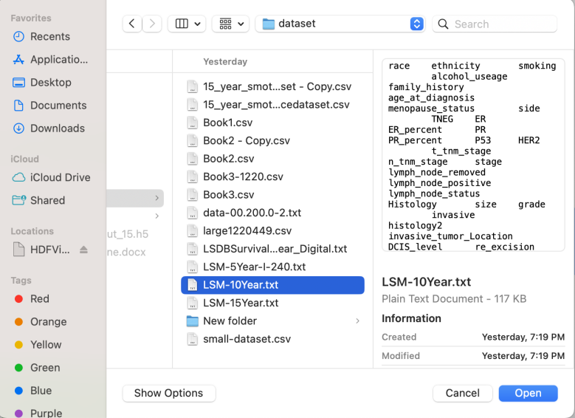

1. View the information of your dataset

There will be a pop-up window to show your dataset in the form format and information about your dataset in the text format.

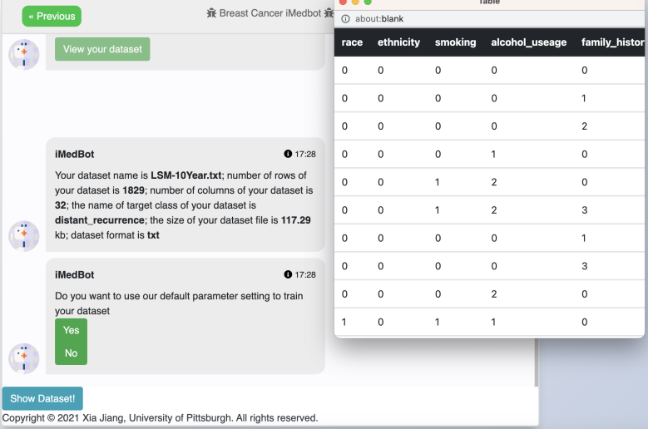

1. Choose whether to use our default parameter setting to train the example dataset

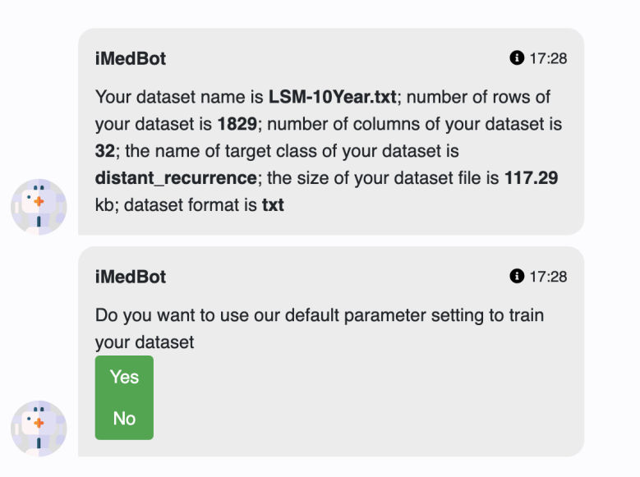

1. Use default parameter setting

After choosing this you will see the list of parameter and explanation will be provided when hovering around the parameter names.

If you choose to change mind, the system will redirect to user defined parameter setting.

If you choose yes, the model begins training. Wait until the system returns results.



2. Use user defined parameter setting

You can input the parameters by yourself. There will also be explanations for the name of parameters when hovering around.

Click submit and wait for the training process.





f. See the training result

It will show the validation AUC value and validation ROC_curve plot. And explanation of AUC_ROC will be provided if you are not familiar with it.



**3.4 Test with new patients**

1. To test a new patient, you need to fill out the patient form and select whether to plot shap analysis

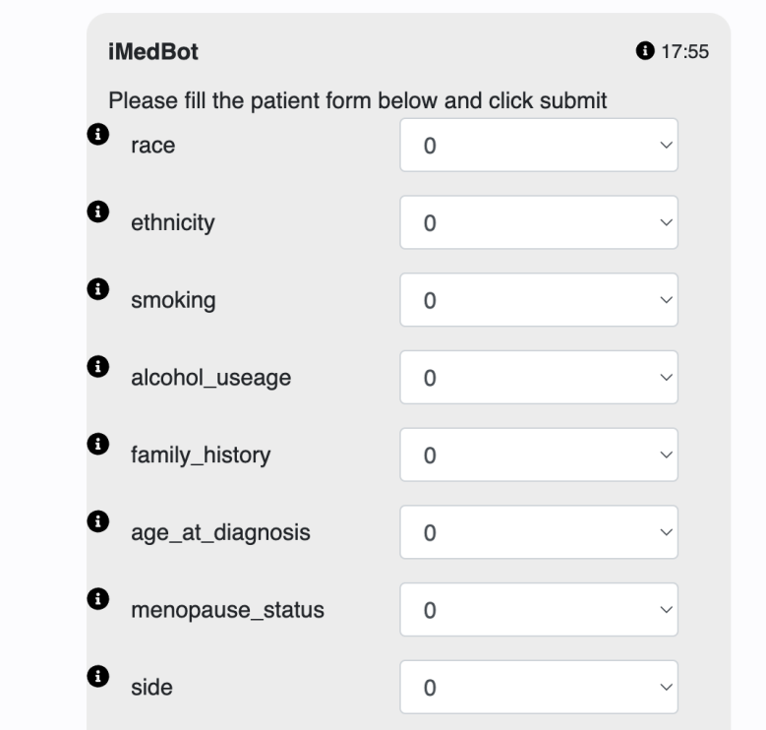

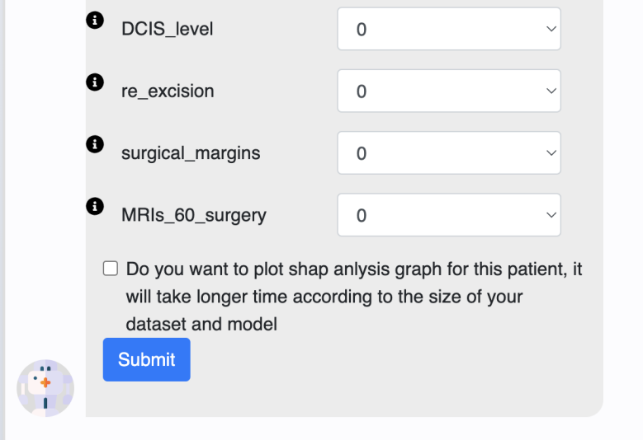

1. Click submit and wait for the result. ( If you choose to plot shap, it may take up to 2 minutes to generate. )

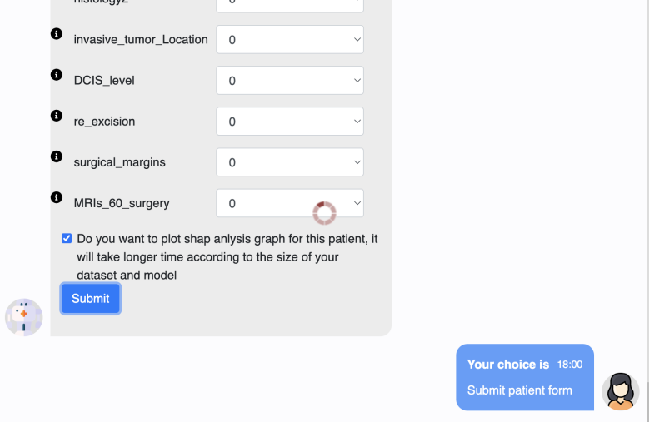

1. See the result

You will see the chance of target feature and shap plot ( only if you choose shap).

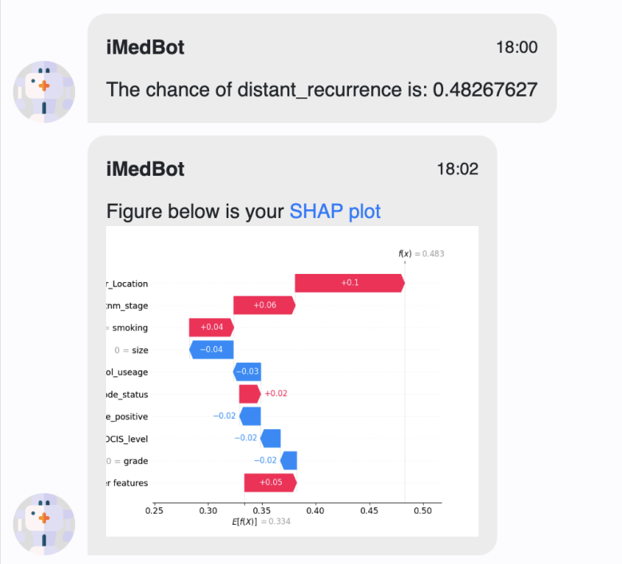

**3.5 Retrain the model**

If you choose to retrain the model, you need to input the parameter again and the other process is the same as training with example dataset or local dataset.

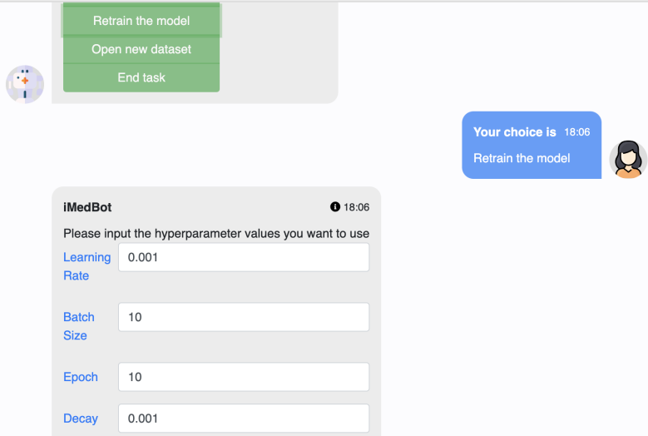

**3.6 Open new dataset**

The process is the same with 3.3 upload local dataset.

**3.7 End task**

You will need to choose whether to take a survey. If you choose yes, please refer to the survey system. If you choose no, the website will refresh and go to the initial state.



**4 Survey system**

If you choose to take a survey, you need to rate the service and leave the suggestions.

You can also keep it blank but we still hope to get valuable feedback from you!

